**OTANCHE BOYACÁ**

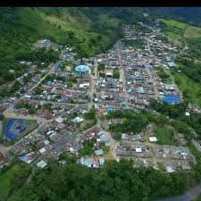

**TOURIST  PLACES**

**1. THE SERRANIAS OF THE QUINCHAS  2. THE LAGOON OF EIGHT**

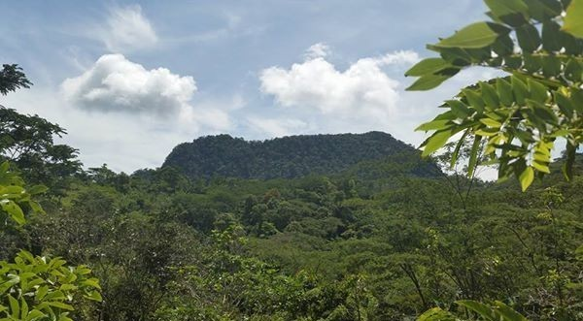 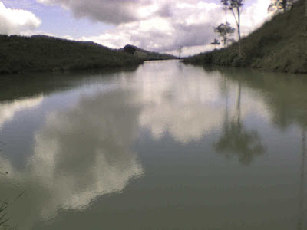

**3. THE LAGOON OF THE LETICIA  4. THE CRYSTALLINE**

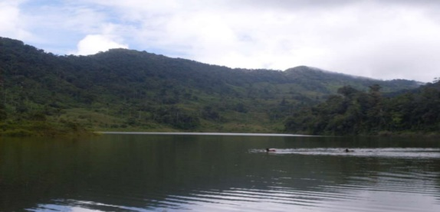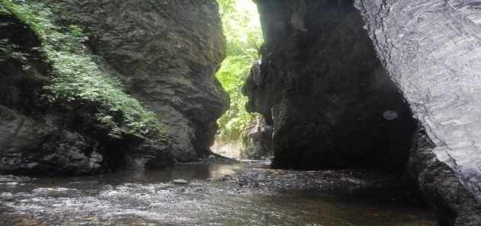

**5. THE POOP  TYPICAL MEALS: THE CHICKEN SANCOCHO**

